Description: MC900052882[1]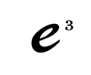**Learning-Focused Strategies Extending/ Refining Lesson Plan: EATS**

**6th Grade: Pardee Unit 7 – History of Latin America Date:**

|  |  |  |  |  |  |  |  |  |  |  |  |  |  |  |  |  |  |  |  |  |  |  |  |  |  |  |  |  |
| --- | --- | --- | --- | --- | --- | --- | --- | --- | --- | --- | --- | --- | --- | --- | --- | --- | --- | --- | --- | --- | --- | --- | --- | --- | --- | --- | --- | --- |
| |  |  | | --- | --- | | **Title:** | Compare and Contrast | | **Type:** | Lesson Plan | | **Subject:** | Social Studies | | **Grade Range:** | 6 | | **Description:** | Latin American Liberators | | **Duration:** | 50+ Minutes | | **Author(s):** | Katie Pardee | | | | | | | | | | | | | | | |
| Instructional Unit Content | | At the end of this unit the student will understand that   * **Cultural interaction leads to cultural diffusion.** * **Nationalism plays an important role in the development of nations.**   In this unit, students will understand how European contact changed the cultural landscape of Latin America. While the early civilizations were destroyed there remains some continuity seen through existing societies. Conflict & change are furthered through the ideas and impact of revolutionary leaders. Students will explore how the movement & migration of people during the building of colonial empires resulted in an economic and cultural legacy. Students will also analyze the impact of nationalism and guerilla movements on the development of modern Latin America and how this conflict brought about change. Students will explore the organizational structure of specific Latin American countries and determine why different governments exist in this region | | | | | | | | | | | | |
| **E** | **Standard (s)** | **SS6H2 The student will explain the development of Latin America and the Caribbean from European colonies to independent nations.**  c. Explain the Latin American independence movement; include the importance of Toussaint L’Ouverture, Simon Bolivar, and Miguel Hidalgo. | | | | | | | | | | | | |
| **TAG Standard** | **Creative Thinking & Creative Problem Solving Skills**   * The student questions accepted practices, rules, and existing principles to discover new knowledge. * The student demonstrates skills in fluency and flexibility to solve problems or create new products.   **Higher Order and Critical Thinking Skills**   * The student conducts comparisons using criteria. * The student responds to questions with supporting information that reflects in-depth knowledge of a topic. * The student predicts probable consequences of decisions. * The student identifies and illustrates basic principles and the foundational concepts that are central to understanding the essence of a field of study | | | | | | | | | | | | |
| **Summary/ Overview** | The focus of this lesson is to identify and understand the motivations and connections that Latin American liberators have in gaining their freedom from their European colonizer through the use of a compare and contrast model. | | | | | | | | | | | | |
| **Enduring Understanding** | CONFLICT and CHANGE: The student will understand that when there is conflict between or within societies, change is the result.   * How did Latin America gain independence from Spain, Portugal and France? * Why were Toussaint L‘Ouverture, Simon Bolivar and Miguel Hidalgo important in the independence movements of Latin America? | | | | | | | | | | | | |
| **Essential Question** | When is conflict most likely to occur and why? | | | | | | | | | | | | |
| **Concepts to Maintain** | **CONCEPT: Conflict and Change**   * Colonization * Liberation * Oppression | | | | | | | | | | | | |
| **Evidence of Learning** | **What students should know:**   1. The history of the region as it specifically pertains to the land that is presently known as Latin America (Haiti, Venezuela) 2. There are similarities and differences in the reactions and motivations of Simon Bolivar and Toussaint L’Ouverture when confronting their European colonizers over the land. 3. Both Liberators had valid arguments as to why they should possess this land today.   **What students should be able to do:**  a.       Conduct comparisons using criteria.  b.      Examine an issue from more than one point of view.  c.        Identify stereotypes, biases, and prejudices in one’s own reasoning and that of others. | | | | | | | | | | | | |
| **Suggested Vocabulary** | * Toussaint L’Ouverture * Simon Bolivar * Miguel Hidalgo * Freedom * Oppression | | | | | | | | | | | | |
| **PROCEDURES** | | | | | | | | | | | | | | |
| **A** | **PHASE 1: Hook/**  **Activating Strategy** | KWL  Wordsplash | Draw Pic/Diagram  Brainstorm | | | Analyze Picture  Anticipation Guide | | | | Activating Acrostic  Dear Teacher | | Sponge  Other: | | |
| **Details of Activator:**  Teacher will hand out the hook, a picture of chain breaking (see handout #1). Students will be instructed to take a moment to look at the picture in silence for 1 minute. After that minute, students will be asked to reflect on the following questions: 1. Make sense of the picture (what does it mean to you) 2. How does this picture relate to Social Studies? 3. How do you think this picture relates to Latin America? (give students time to reflect- about 3 minutes). When 3 minutes is up, tell students to S-C-L (play Stop-Collaborate – Listen clip 8 sec clip of the beginning of Ice-Ice-Baby) (this is my version of sharing with a neighbor. Allow students to share with a neighbor and then discuss their thinking as a whole group. | | | | | | | | | | | | |
| **T** | **Teaching STRATEGIES**: | Peer Tutoring  Simulations  Hands On | | Lecture  Independent Activities  Cooperative Learning | | | Visuals  Graphic Organizers  Pairings  Centers | | | | Whole group instruction  Projects  Technology Integration | Guided Reading  Response Cards | | Gallery Walk  Quick Write  Other: |
| **Differentiation**  **STRATEGIES**: | Anchor Activities  Choices of Review  Flexible grouping/ seating | | | Simulations  Games  Centers | | | Centers  Lit Circles  Cubing | Menus/ Choice Boards  Multiple levels of questions | | | | Think-Pair- Share  Interest Groups  Multiple Intelligence | Jigsaw  Varied Modes of Products  OTHER: |
| **PHASE 1-4:**  **1: Description**  **2.Comparison**  **3: Conclusion 4. Application**  **(Learning Plan)** | Phase 1: Description   1. Distribute the readings on Toussaint L’Ouverture and Simon Bolivar. Each person will read his/her assigned piece and complete the **criteria organizer**. 2. **Pair** students with like assignments to discuss criteria organizer. 3. Students will pair with someone who completed the opposite reading (i.e., each Toussaint L’Ouverture with a Simon Bolivar). Each student will **teach his/her partner** what s/he knows.   Phase 2: Comparison   1. Distribute **Visual Organizer**. Groups of four will work together to complete a visual organizer (i.e., two Toussaint L’Ouverture and two Simon Bolivar).   Phase 3: Conclusion   1. In a class discussion, groups will share **general statements** about the roles of freedom and liberators and their relationships with one another. Instructor will record class responses.   Phase 4: Application   1. Distribute **Think-Tac-Toe** and explain the directions. Each student will select and complete three of the activities. | | | | | | | | | | | | |
| **S** | **Summarizing STRATIGIES (Students are doing the summarizing)** | **Answer EQ  Journal Entry  ABC Summary  One Minute Essay  Index Card Summary  Debriefing   Hand Signals  TOTD  Oral Questioning  Other: Sum it Up!**  **Details of the Summarizer (What are students doing?):** | | | | | | | | | | | | |
| **Resources** | | **Anchor Text(s):**  **Technology:**  S-C-L Clip  **Handouts:**  Handout 1: Hook  Handout 2: Student Handout #1- Role and Relationships  Handout 3: Student Handout#2- Venn  Handout 4: Student Handout #3- Compare and Contrast Synthesis Activities Handout 5: TOTD Handout 6: Readings- Toussaint L’Ouverture Handout 7: Readings- Simon Bolivar | | | | | | | | | | | | |

**Handout #1- Hook**



1. Make sense of the picture (what does it mean to you)

2. How does this picture relate to Social Studies?

3. How do you think this picture relates to Latin America?

**Handout #2- Role and Relationships**

**Name: _________________________________________________________ Date:_______________ Period:_____________**

**Role and Relationships**

Student Handout 1

You will be assigned one of the two passages to analyze. Read the passage. Using the criteria given describe the passage focusing on the roles, the background, the location, and their motivation for liberation. Be prepared to share.

|  |  |  |
| --- | --- | --- |
| **Toussaint L’Ouverture** |  | **Simon Bolivar** |
|  | Background (Life)  Location  Role of the liberator  Motivation for Liberation |  |

**Handout #3- Venn**

**Name: _________________________________________________________ Date:_______________ Period:_____________**

**Role and Relationships**

Student Handout 2

Working with a partner or group, compare the two selections by listing similarities and differences based on criteria related to the passage focusing on the roles, the background, the location, and their motivation for liberation. Use the organizer below to list your thoughts.

|  |  |  |
| --- | --- | --- |
| **Toussaint L’Ouverture** | **Similarities** | **Simon Bolivar** |
|  |  |  |

**Handout #4- Compare and Contrast Synthesis Activities**

**Name: _________________________________________________________ Date:_______________ Period:_____________**

**Compare and Contrast Synthesis Activities**

Learning Log Questions

Based on your analysis, what are some general statements you can make about how the Latin American Liberator’s location impacts a liberator’s conflicts, motivations and reactions?

What universal motivations and reactions of Liberators transcend location?

**Think-Tac-Toe**

In order to extend your learning on how conflict impacts a location and the resulting change that occurs which impacted a Liberator’s motivation and reactions, complete three activities (horizontal, vertical, or diagonal) to win tic-tac-toe.

|  |  |  |
| --- | --- | --- |
| Create a song or poem using the voice of a Liberator of Latin America and explain his reaction to the conflicts he experiences. Incorporate how the location impacted the reaction. | Research the historical facts behind the conflicts of one of the Latin American Liberators. Write a literary critique of the accuracy of the author’s setting and character sketches. | Create a chart diagramming the similarities and differences between the conflicts a liberator of Latin America and a Liberator of another country from another region we have studied. Describe how the conflicts created change within those countries. |
| Select a conflict from one of our Latin American Liberators and create poster/flow chart detailing how the conflict impacts the Liberator motivations and reactions. | Wild Card  Create your own activity to extend your learning of how authors use setting to define a character’s motivations and reactions.  You must complete a learning contract and have it approved by the teacher before beginning the activity. | Role play a conflict between two liberators of Latin America. Change the location and role play the conflict again. How do the Liberators’ motivations and reactions change? |
| Reflect upon what you have learned about how location can impact a Liberator’s conflict, motivations and reactions. Write a journal entry on how your motivations and reactions are impacted by your surroundings and the conflicts you experience. | Create a skit in which one or more Liberators from Latin America appear on an afternoon talk show such as Oprah or Dr. Phil to discuss a major conflict they experienced and the change they experienced from that. | Develop a hypothesis for how humans will react to a certain situation or conflict and the change those results. Create an experiment to test this hypothesis. |

**Handout #5- TOTD**

**Name: _________________________________________________________ Date:_______________ Period:_____________**

TOTD

Considering the conflicts experienced by the Latin American Liberators, were their results of their actions similar of dissimilar? Explain how and why with evidence from your learning. *Extension: Illustrate your response.*

**Answer the Essential Question:** When is conflict most likely to occur and why?

**Handout #6-** Readings- Toussaint L’Ouverture

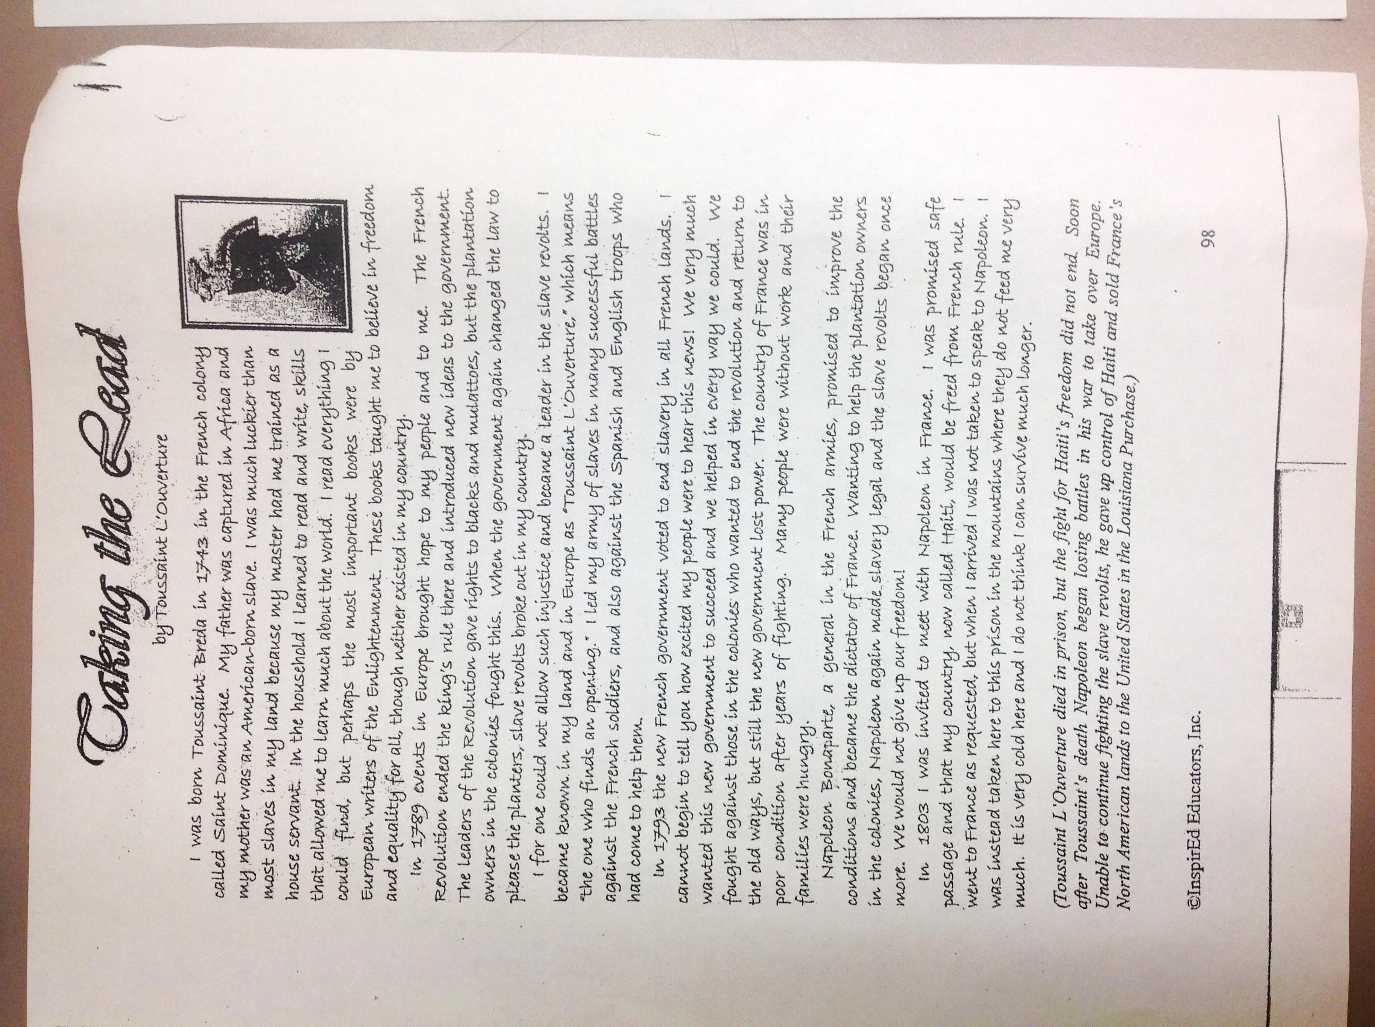

**Handout #7-** Readings- Simon Bolivar

